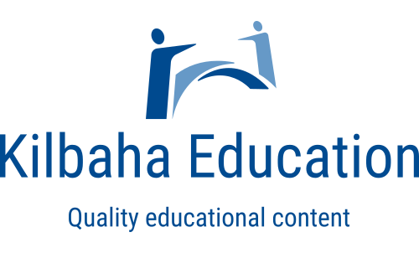
DETAILED ANSWERS TO ACARA NAPLAN TESTS 2008-2021

13 SETS OF ANSWERS FOR EACH SUBJECT IN EACH YEAR LEVEL
School site licence to reproduce for all teachers and students

Supplied in both WORD (for easy editing) and PDF (for easy printing)

Kilbaha Education (Est. 1978) (ABN 47 065 111 373)  PO Box 2227  Kew Vic 3101 Australia | Tel: (03) 9018 5376  Email: kilbaha@gmail.com  Web: https://kilbaha.com.au

SCHOOL ORDER NUMBER (required)_________________________DATE_________________________

NAME_________________________________________________________________________________

SCHOOL______________________________________________________________________________

ADDRESS_____________________________________________________________________________

POSTCODE_______________TEL__________________________________

EMAIL ________________________________________________________________________________

Please mark (X) those required.

 | Detailed answers and responses to  ACARA NAPLAN tests 2008-2021  THIRTEEN (13) SETS OF ANSWERS FOR EACH SUBJECT IN EACH YEAR LEVEL  WORD and PDF for all answers  QUESTIONS NOT INCLUDED | Price |  |  | Detailed answers and responses to  ACARA NAPLAN tests 2008-2021  THIRTEEN (13) SETS OF ANSWERS FOR EACH SUBJECT IN EACH YEAR LEVEL  WORD and PDF for all answers  QUESTIONS NOT INCLUDED | Price
 | Year 3 Language | $30 |  |  | Year 5 Language | $30
 | Year 3 Numeracy | $30 |  |  | Year 5 Numeracy | $30
 | Year 3 Reading | $30 |  |  | Year 5 Reading | $30
 | Year 3 Writing | $30 |  |  | Year 5 Writing | $30
 | Year 7 Language | $30 |  |  | Year 9 Language | $30
 | Year 7 Numeracy | $30 |  |  | Year 9 Numeracy | $30
 | Year 7 Reading | $30 |  |  | Year 9 Reading | $30
 | Year 7 Writing | $30 |  |  | Year 9 Writing | $30

Want to save money? Buy the bundles below.

 | YEAR 3. All 52 sets of answers for each of Language, Numeracy, Reading, Writing | $99.95
 | YEAR 5. All 52 sets of answers for each of Language, Numeracy, Reading, Writing | $99.95
 | YEAR 7. All 52 sets of answers for each of Language, Numeracy, Reading, Writing | $99.95
 | YEAR 9. All 52 sets of answers for each of Language, Numeracy, Reading, Writing | $99.95

Total Amount = $_____________ (All prices include GST)

Email to kilbaha@gmail.com

