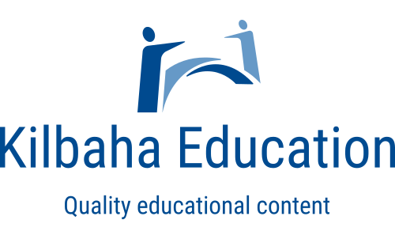 | Get started with AI!  AI generated responses for questions on English Texts  Questions for students about AI

Kilbaha Education (Est. 1978) (ABN 47 065 111 373)  PO Box 2227  Kew Vic 3101  Australia | Tel: (03) 9018 5376  Email: kilbaha@gmail.com  Web: https://kilbaha.com.au

SCHOOL ORDER NUMBER (required)_________________________DATE_________________________

NAME_________________________________________________________________________________

SCHOOL______________________________________________________________________________

ADDRESS_____________________________________________________________________________

POSTCODE_______________TEL__________________________________

EMAIL ________________________________________________________________________________

These publications from Kilbaha Education are digital and are supplied to the purchasing
with a school site licence to reproduce for students in both print and electronic formats.

Please mark (X) those required.

 | AI analytical responses generated by https://chat.openai.com/  Supplied in WORD format for easy editing.  Questions for students about AI. | Cost
 | How does All the Light We Cannot See relay the role of fate in one’s life? | $10
 | In his novel All the Light We Cannot See, Doerr suggests that love of learning is a powerful force.’ Discuss. | $10
 | ‘In times of conflict, the characters in All the Light We Cannot See demonstrate both the best and the worst of human behaviour.’ Discuss. | $10
 | “We rise again in the grass. In the flowers. In songs.”  ‘Despite the bleak circumstances that face the characters, Doerr relays moments of insightful optimism.’ Discuss. | $10
 | ‘The societal pressures and expectations that Austen explores in Pride and Prejudice overwhelm all of her characters.’ Discuss. | $10

Total Amount = $_____________ (All prices include GST)

Email to kilbaha@gmail.com

