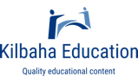
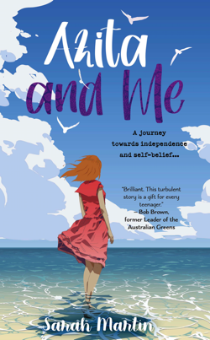

Azita and Me

A Novel by Sarah Martin

Kilbaha Education (Est. 1978) (ABN 47 065 111 373)  PO Box 2227  Kew Vic 3101  Australia | Tel: (03) 9018 5376  Email: kilbaha@gmail.com  Web: https://kilbaha.com.au

SCHOOL ORDER NUMBER (required)_________________________DATE_________________________

NAME_________________________________________________________________________________

SCHOOL_______________________________________________________________________________

ADDRESS_____________________________________________________________________________

POSTCODE_______________TEL__________________________________

EMAIL ________________________________________________________________________________

The Book: Holly has been keeping a low profile at school to avoid situations where the class bully can make unkind comments about her single sex parents and exclude her. Her strategy is upset when Azita, an Iranian refugee, joins her Year 7 class, and they become friends. The two girls are opposites, and Holly's world expands in unexpected ways. It will take her on a journey towards independence and self-belief and towards a greater understanding of the natural world. She will have to contend with grief and learn how to live with it and grow beyond it. Set in an imaginary coastal town in Queensland, Holly's perceptive and captivating account will resonate across all age groups as she grapples with personal uncertainty and tragedy to hope for a better world.

The Author: Sarah Martin can't remember a time when she didn't want to be a writer. As a child she wrote short stories for her family as Christmas presents. But it took a series of extraordinary events to jumpstart her career as a writer after twenty years as a secondary school teacher and ten as a fundraiser. In 2012 she published a biography, followed by two histories and a children's picture book. During lockdowns in Melbourne throughout COVID-19 in 2020 and 2021, she indulged her secret passion for writing fiction, and completed four novels, Azita and Me being the first to be published. She has discovered almost by accident that much of her writing is inspired by her exploration and love of the natural environment, which has meant she has had to confront the connected issues of climate change. She sees her fiction as a means of expressing these interests in a creative and non-confrontational way.

Number of Copies | Book Details | School Price per Copy
 | - Azita and Me  - Format Paperback | 172 pages  - ISBN 9781925707823 | $19.95
A Resource Rubric that aligns with the Australian Curriculum to bring the book to life
and stimulate discussion. School site licence for print and electronic use. $5.00

Total Amount = $_____________ (All prices include GST and postage anywhere in Australia)

Email to kilbaha@gmail.com

